**STRUCTURED PYRAMID ANALYSIS PLAN**

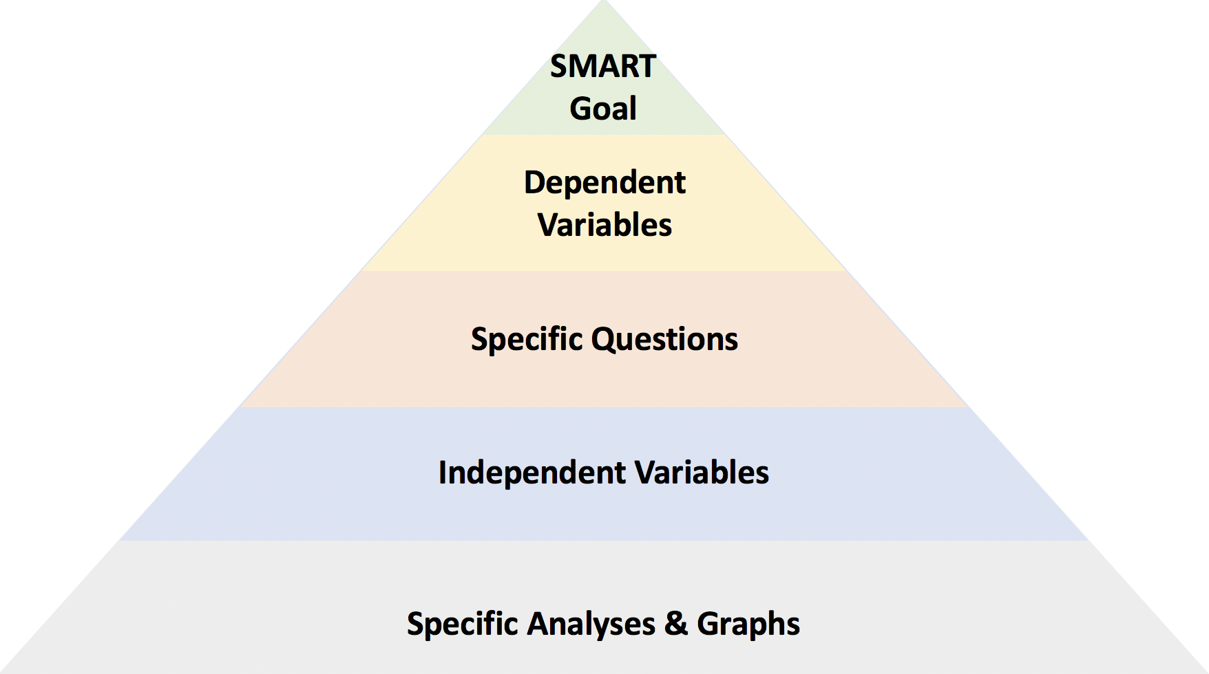

**SMART GOAL:** To reduce the number of employees leaving the company by at-least 5% in a year.

**DEPENDENT VARIABLE:**

* The dependent variable for our project is attrition.
* We will determine whether an employee will leave the company or not. If yes, then identify the factors and try to reduce them.

**INDEPENDENT VARIABLE:** The independent variable or attributes which are contributing factors towards an employee’s decision to quit.

* Age – What is the age of the employee.
* Daily Rate – What is their daily wage.
* Business Travel – How frequently they travel for business purpose.
* Department – Which department do they work under.
* Distance from home – How far is the office from the place they live.
* Education field – What educational background they have.
* Environment satisfaction – How much satisfied they are in their working environment on the scale of 1 to 4.
* Gender – Whether the employee is male or female.
* Hourly Rate – What is the employee’s hourly wage.
* Job involvement – How productively the employees are engaged in their jobs on the scale of 1 to 4.
* Job level – What level does the employee is positioned in the company.
* Job role – What is role of the employee in their job.
* Job satisfaction – How satisfied they are with their job on the scale of 1 to 4.
* Marital Status – Whether the employee is married or single.
* Number of companies worked in – How many companies have the employee worked in before joining this company.
* Over time- How many hours did the employee worked over the designated hours.
* Salary hike – If they received any increment in their salary and by how much.
* Performance rating – How was their performance rated on the scale of 1 to 4.
* Stock option level: Whether the employee has any stocks of the company or not.
* Total working years – How many years of experience does the employee has in total.
* Work life balance – Work-life balanced measured on the scale of 1 to 4.

**SPECIFIC QUESTIONS:**

* Determining the factors which have the most impact on an employee’s decision to quit the company.
* Determining the age group and gender which are more likely to leave the company.
* Draw out some prescriptive measures to reduce the likeliness of employees quitting the company.

**KEY PERFORMANCE INDICATOR:**

* Reduction of number of employees leaving the company is our desired outcome
* By determining the factors, we would be able to give a prescriptive measure on how those factors could be eliminated or reduced to keep loyal and deserving employees within the company
* The progress can be measured when all these factors would be detected and reviewed in test data set
* We can influence the outcome by figuring out that what factors are affecting the employee’s interest and what constraints should be changed to increase the employee’s interest
* The constraint for the factor or variable that are affecting our outcome is responsible for the business
* We can say that our goal is completed when we will be able to reduce the number of employees leaving the company by determining the factors
* We can review our program weekly or monthly towards the outcome